# Recommendation System

**Problem Statement:** Recommend a best book based on the author, publisher and ratings

Step 1: Install Packages matrix and recommender lab.

Step 2: Read the data file.

Step 3: Create a histogram to determine the data distribution.

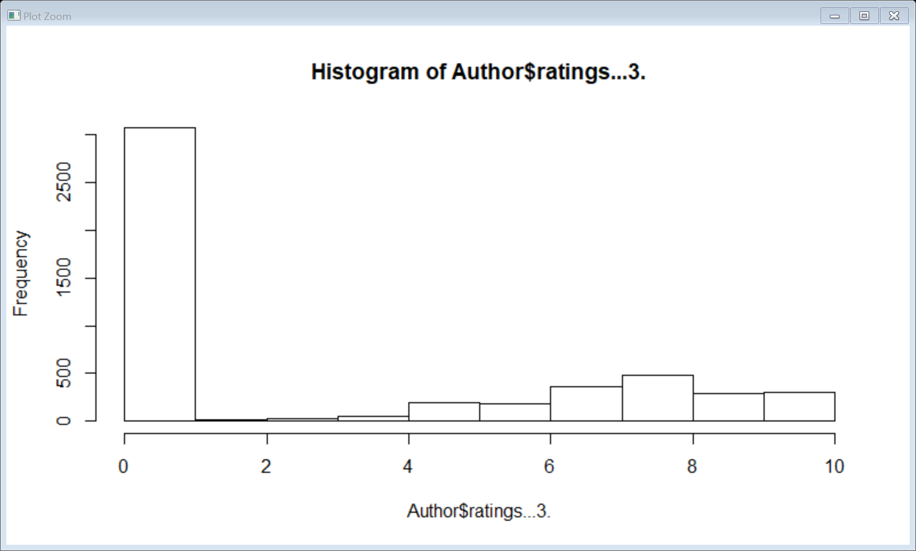

Step 4: The datatype should be realRatingMatrix inorder to build recommendation engine.

Step 5: Based on the popularity Predictions for two users the recommendation is “48”- Isl of Dogs.

Step 6: Popularity model recommends the same book for all users , we need to improve our model using Collaborative Filtering so based on that the recommendation based on rating is “48” which is - Isl of Dogs.

Step 7: Based on Author 1344 Horward Norman and 1977 Pat Rodegast

Step 8: Based on Publisher Alvim, Boon, Breakfasts 1997 (Annual); Tracey Menges; 1996;Thomas Nelson, Brownies;G &amp, Vicki Lansky;1991;Book Peddlers.

Step 9: when you combine all the variables ie publisher, author,ratings we get the recommendation as follows Based on the popularity Predictions for two users the recommendation -"2" "3" "4" "5" "6"

Step 10: After combining all the variables in dataset ,Popularity model recommens the same book for all users , we need to improve our model using Collaborative Filtering so based on that the recommendation based on rating is "26" "27" "28" "29" "30".